Credit Score Documentation
Introduction:
In the banking sector, especially with the increasing popularity of installment-based purchasing. Customers can easily finance any product that they can’t pay upfront. While this system offers a great service to those customers, it also introduces a risk for the banks and lenders as some customers started to have a hard time paying back what they owed. As a result, banks and lenders started worrying about not getting their money or interest back.
To solve this issue, the credit score system was developed, it’s an important factor that evaluates how likely a customer is to repay their loans on time. The overall goal is to minimize the financial risk by ensuring that money is lent to customers who can pay it back.
Description:
The Credit Score dataset from Kaggle provides a comprehensive history of customer financial behavior and credit score. It contains roughly 100,000 rows and 28 columns, making it a perfect dataset for analyzing the relationship between different financial attributes. The goal here is to be able to predict whether a customer will receive a Good, Standard, or Poor credit score. Which is a multi-class classification problem. This dataset is interesting because of its scale and complexity. The dataset contains many categorical and numerical features. Here is a list of all the features found:
- Age  - Occupation  - Annual Income  - Monthly Inhand Salary  - Num Bank Accounts  - Num Credit Card  - Interest Rate  - Num of Loan  - Delay from due date  - Num of Delayed Payment  - Changed Credit Limit | - Num Credit Inquiries  - Credit Mix  - Outstanding Debt  - Credit Utilization Ratio  - Credit History Age  - Payment of Min Amount  - Total EMI per month  - Amount invested monthly  - Payment Behaviour  - Monthly Balance  - Credit Score
The target feature is a categorical attribute which is the Credit Score. Let’s start the preprocessing, data cleaning, and analysis.
Importing Libraries & Dataset:
Important libraries such as (numpy, pandas, seaborn, matplotlib, sklearn and mlxtend)
Data Cleaning & Preprocessing:
Dropping Columns:
After inspecting the data, some features are unnecessary. Such as the ['ID', 'Customer_ID', 'Month', 'Name', 'SSN', 'Type_of_Loan'].
For ID, Customer, Month, Name, and SSN. These values do not have an impact on the financial behavior. While the type of loan may have an impact, the values given by the dataset are not useful at all. For these reasons, these features got dropped to help simplify the cleaning process and reduce model complexity.
Handling duplicates:
Checked for duplicates and found none.
Splitting data:
The data I’m working on needs to be split into two parts, one for the training, and one for the testing. The reason is that we need to test the trained model on a new dataset that the model has never seen before.
The original data will be split into 80% train, and 20% for testing.
Handling datatypes:
Some data types are supposed to be numerical, or basically numbers, such as the Age, the Income, Number of loans, monthly balance, etc. These columns I changed their datatype to numerical.
Normalizing data:
Some of the data is not clean, for example some of the numeric columns mentioned above have random underscores (_). These impurities were handled by removing.
For the Age column a lot of values are under 18, above 100, and some even are negative. These values were clipped so the age is between 16 till 100, all the other values were replaced by null values.
The credit history age column is written as a string for example “5 Years and 3 Months”. A function was used to strip the numbers, multiple the years by 12, and add the months to get a result of 63 months.

Handling nulls:
For the Age, I took the mean value of the ages and filled the nulls with it for both the train and the test. Keep in mind that only the mean from the train was used to fill the test to prevent data leakage.
After inspecting the numeric columns, these are the percentage of null values in my columns:
- Monthly_Inhand_Salary: 15%  - Num_of_Delayed_Payment: 9.75%  - Credit_History_Age: 9%  - Amount_invested_monthly: 8.75%  - Annual_Income: 7% | - Num_of_Loan: 5%  - Changed_Credit_Limit: 2%  - Num_Credit_Inquiries: 2%  - Monthly_Balance: 1.2%  - Outstanding_Debt: 1%
Now, in order to handle these null values, I have three options either to drop these values, fill them with mean, or with median. The first option would reduce the total number of rows. So, I will stay with the other method which is filling with either mean or median. Even though these methods are very similar but choosing them is very critical.
In order to know which one to choose, first you must visualize the data, if the data Is normally distributed, then you can use the mean. However, if the data is skewered to the right or left, then using the median would be the optimal solution.
Another way is to calculate the difference between the mean and the standard division. If the relative difference is low, then you can use the mean, if it’s high then you must use the median. This is done to ensure that the values are filled correctly.
Keep in mind that all the fillings were also done on the test, using the mean and median values of the train data.
Handling Outliers:
While some of the issues with the data is that it’s missing, written incorrectly, or generally wrong. Sometimes more logical errors can be discovered by checking the distribution of the data to discover outlier values. This is done using the IQR method which splits the data into lower 25% and upper 75% and gets the difference. At the end this creates something like a boundary value inside it are perfectly fine, but values outside are considered outliers or more likely errors.
These values outside that range I clipped their values to the boundaries limits to ensure that a single data point outside the normal range doesn’t affect the whole data.

Encoding:
It’s well known that most models don’t understand strings or objects, that’s why we need to change data types to numerical values. But what about categorical values? These values are very important and have a huge impact on the target feature but are not numerical. To solve this issue, categorical values are going to be represented as numbers (0,1,2,3…). For example, in the ‘Occupation’. It has many job titles such as Engineer, Mechanic and more. Simply by encoding it it’s going to either change the column to numeric values say 1 represents an engineer, and 2 represents a mechanic and so on or simply you’re just going to add multiple Boolean columns.
For categorical values with more than 3 features, I used one-hot encoder, which is the method in which each feature is split into its own column. But for other categorical values with 3 or less features, I used regular label encoding.
Feature Engineering:
At this step, I can easily add new features based on features that I already have. This step helps to increase overall accuracy by providing new relationships. As an example, I can calculate the total dept to income ratio by dividing the outstanding debt over by the monthly salary.
Feature Selection:
At this phase the goal is to figure out which features are most important, or the features that have a high correlation with the target feature. I used 3 methods:
- Correlation Matrix: Plot the features and check the values visually and drop the features that don’t have a high correlation with the target nor any other feature.
- Selection by variance: Used the variance against the “Credit_Score” and removed features with low variance.
- Step Forward: Used a KNN model to try different combinations of features to select the highest performing features.
Data Splitting:
Recall that I used 3 different methods for feature selection, and by using each, I got a completely different dataset. For that reason, I decided to split my data and retain a copy from the data at each step. I then decided to train each model 4 different times on each data to also compare between them and show which feature selection method is the best. The datasets I ended up with are as follows:
- train_original: This dataset contains the original data without any feature selection this would serve as the baseline. It contains 44 features. (Regular_Data)
- train: This is the original dataset but after applying correlation matrix selection techniques. It contains 29 features. (Regular_Corr)
- train_variance: This is the original dataset but after applying selection by variance method. It contains 10 features. (Regular_Varriance)
- train_SFS: This is the original dataset but after applying step forward selection. It contains 4 features. (Regular_SFS)
Each dataset was split into X_train, Y_test, X_test, and Y_test. The _test datasets only contain the target feature, while the _train, contains the other features. This is needed to first train the model on the X_train, and then assess its accuracy based on the answers from Y_train. Then the model is used on Y_train (which is the new unseen data) and assessed based on the answers from Y_test.
Training:
I used 3 different models for training, and each model has its own pros and cons. Here is the list of the models used:
- Logistic Regression: This model is the simplest as it only works well with linear data. This model will serve as the baseline for comparison.
- Decision Tree Classifier: This model is a better version of the previous model, as it can handle nonlinear data and works well with mixed types of data (numerical and categorical). However, this model is well known for overfitting.
- K-Nearest Neighbors (KNN): This model is a non-parametric model, that doesn’t assume a specific data distribution, which is useful for detecting local patterns.
For logistic regression, and KNN these models, can be biased when the difference between the numerical data is large, for example having an age column that has numbers from range between (16-100), and having the income column that has values in the millions will cause the model some issues. So, I solved this by normalizing the data using StandardScaler.
Another important thing when it comes to training models is the hyperparameters. These are parameters used for settings boundaries, pantalets, choosing limits, or specific functions and much more. Having the perfect hyperparameters will yield in higher accuracy.
An easy way to know which hyperparameters are the best, I will use a method called grid search, this is basically a way of giving the model multiple options and letting the model decide which parameters are the best for its own case based on the accuracy. The only drawback of this method is that it’s computationally expensive. Here are the hyperparameters used for each model:
Logistic Regression | Decision Tree Classifier | K-Nearest Neighbors
- C  - Penalty  - Solver  - L1_Ratio  - StandardScaler | - max_depth  - min_samples_split  - min_samples_leaf  - max_features  - criterion  - ccp_alpha | - n_neighbors  - weights  - metric  - StandardScaler

Results:
The following table shows the results of each dataset using each model, these values are the accuracy of the test:
Data/Models | Logistic Regression | Decision Tree Classifier | K-Nearest Neighbors
Regular_Data | 63% | 66% | 72%
Regular_Corr | 64% | 67% | 71%
Regular_Varriance | 51% | 63% | 70%
Regular_SFS | 53% | 62% | 67%

I will only show the learning graphs of the best performing models, as well as their confusion matrix. I will also be commenting on the performance of the model in terms of overfitting, underfitting, and the false and positive trues.
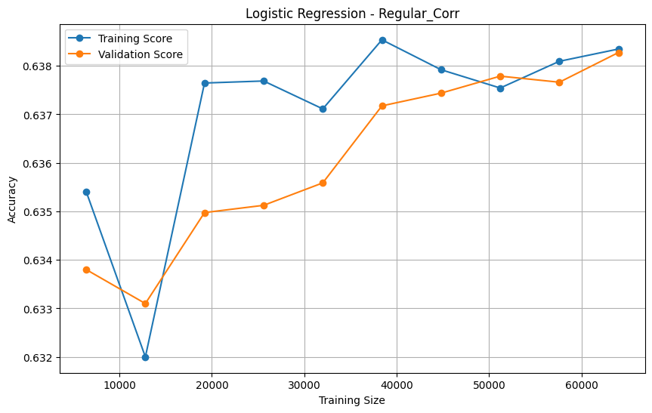
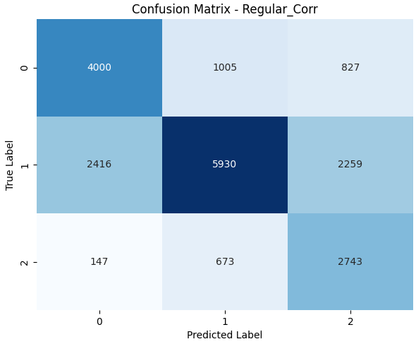
Logistic Regression

These graphs show that the model is not overfitting as the difference between train and test is less than 0.01%, but underfitting, as it only reached an accuracy of 63.8%, which suggests that the model can’t capture any more complex relationships. The model was only able to predict 4000 true zeros, 5930 true ones, and 2743 true twos, but falsely predict 7327.
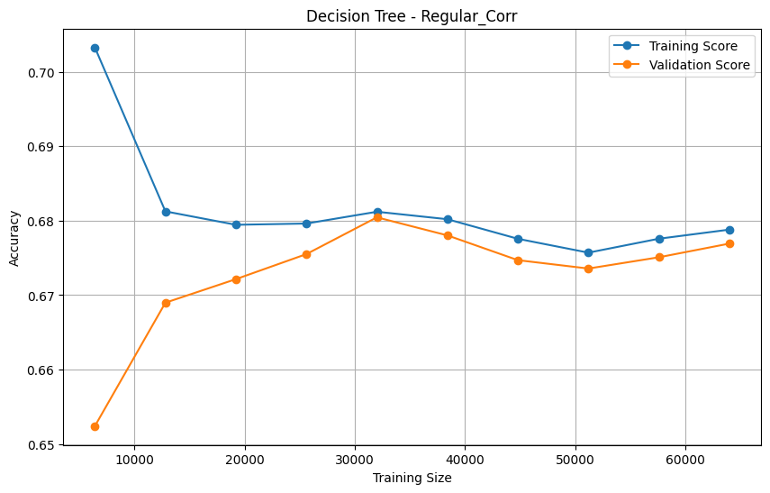
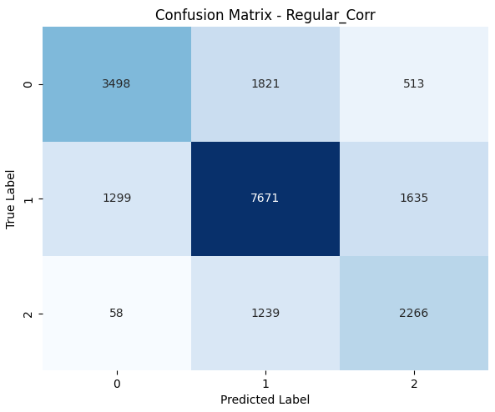
Decision Tree Classifier

These graphs show that the model is not overfitting as the difference between train and test is less than 0.1%, but underfitting, as it only reached an accuracy of 68%, which suggests that the model can’t capture any more complex relationships. The model was only able to predict 3948 true zeros, 7671 true ones, and 2266 true twos, but falsely predict 6565.
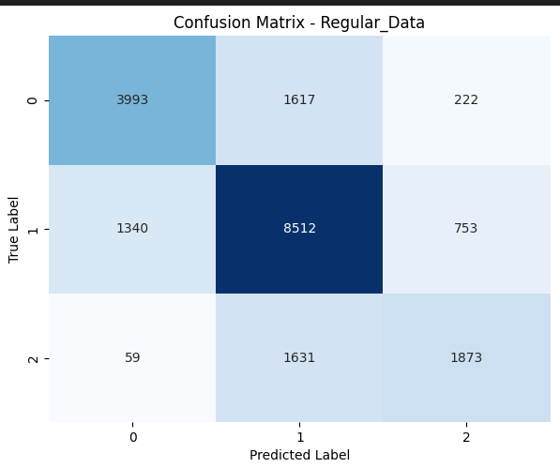
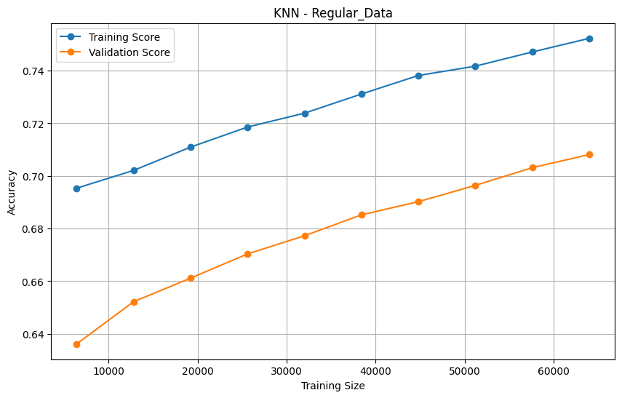
K-Nearest Neighbors

These graphs show that the model is slightly overfitting as the difference between train and test is around 4%, but underfitting, as it only reached an accuracy of 72%, however since the model didn’t have enough data to converge this suggests that the model may be able to capture more complex relationships. The model was only able to predict 3993 true zeros, 8512 true ones, and 1873 true twos, but falsely predict 5622.

